Wireframe for Project: Mass Lotto Under a Microscope

1. Wireframe page one: Home Page (Summary information giving a general presentation of the web application, and how to review the information presented).

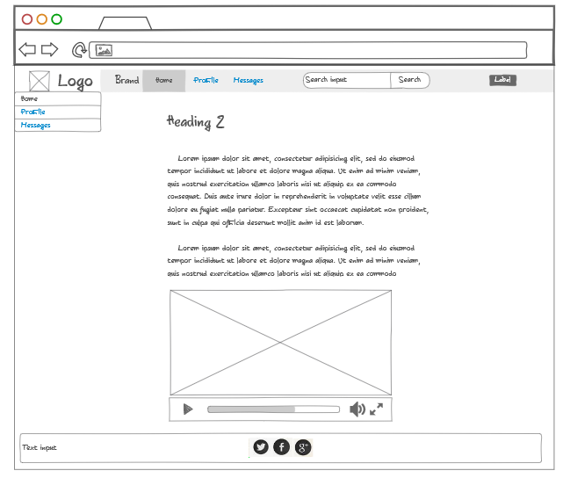

**LOGIN**

**PAYMENT**

**STATISTICS**

**DASHBOARD**

**HOME**

**Statistics**

**Dashboard**

**Home**

Log In

www.masslottomicroscope.com

Footer Space: Contact Info 

2. Wireframe page two: Dashboard page (Gives some graphs pertaining to frequency and time periods).

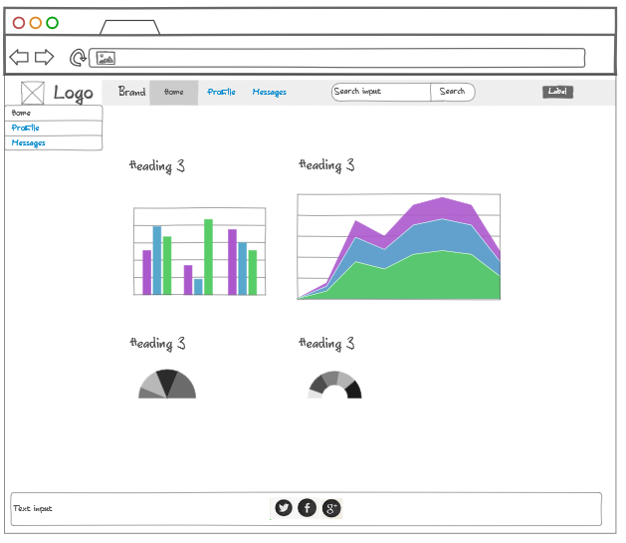

**PAYMENT**

**CONTACT**

Footer Space Contact Info:

**Statistics**

**Dashboard**

**Home**

Log In

www.masslottomicroscope.com

**STATISTICS**

**LOGIN**

**HOME**

**DASHBOARD**

3. Wireframe page three: Statistics page (More information regarding statistics, and extra comment section for ideas and improvements). This could be extra data feeds in raw format to allow user to draw upon their own observations or analysis.

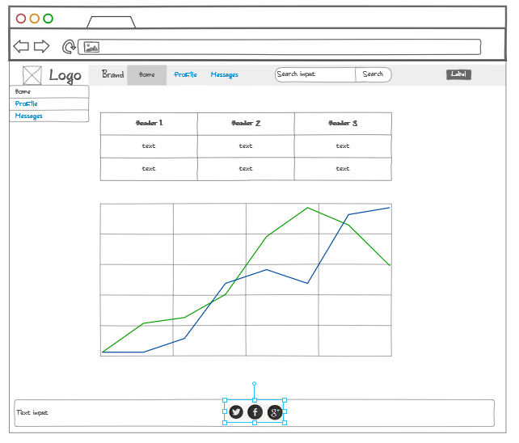

Log In

**CONTACT**

**Statistics**

**Dashboard**

**Home**

**PAYMENT**

**LOGIN**

**STATISTICS**

**DASHBOARD**

**HOME**

www.masslottomicroscope.com

Comments from Users: Opinions from users regarding how to improve predictive analytics

Footer Space Contact Info:

4. Wireframe page four: Login page where users can create an account or sign in with existing user name and password.

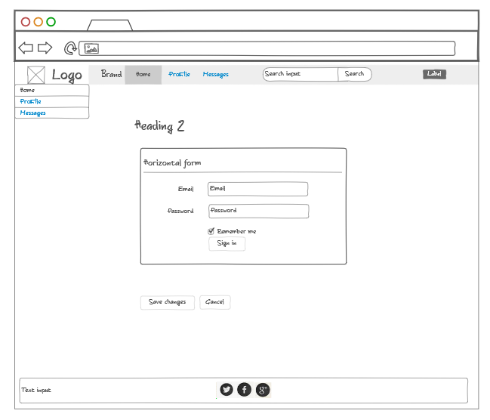

Log In

www.masslottomicroscope.com

Footer Space Contact Info:

**Statistics**

**Dashboard**

**Home**

**CONTACT**

**PAYMENT**

**LOGIN**

**STATISTICS**

**DASHBOARD**

**HOME**

5. Wireframe page five: Payment Page. This might be a donation page instead. Radio button created to show different donation options, and credit card or Paypal account information submittal.

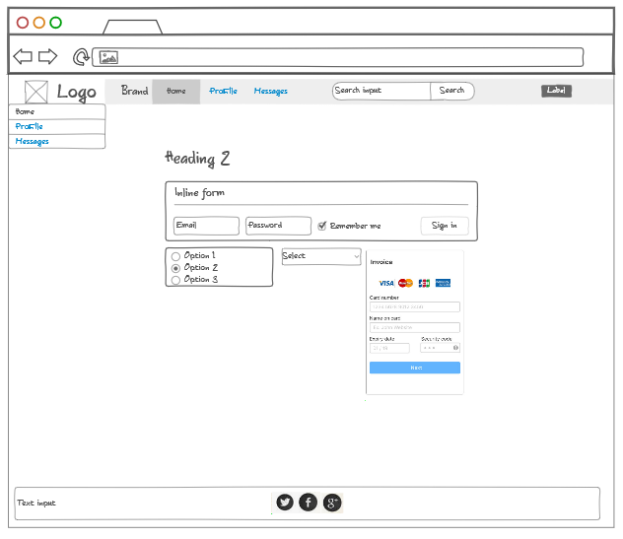

Log In

**Statistics**

**Dashboard**

**Home**

Footer Space Contact Info:

www.masslottomicroscope.com

**CONTACT**

**LOGIN**

**PAYMENT**

**STATISTICS**

**DASHBOARD**

**HOME**

6. Wireframe page six: Contact administrator page. This page allows users to leave comments and suggestions.

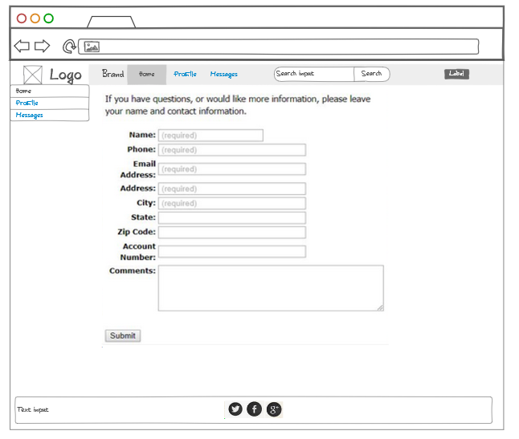

Log In

Footer Space Contact Info:

www.masslottomicroscope.com

**CONTACT**

**PAYMENT**

**LOGIN**

**STATISTICS**

**DASHBOARD**

**HOME**